
RAMAIAH
INSTITUTE OF TECHNOLOGY
USN | 1 | M | S

(Autonomous Institute, Affiliated to VTU)
Bangalore – 560 054

SUPPLEMENTARY SEMESTER EXAMINATIONS – AUGUST 2017

Course & Branch | : | B.E : Computer Science and Engineering | Semester | : | IV
Subject | : | Design and Analysis of Algorithm | Max. Marks | : | 100
Subject Code | : | CS1542/CS413 | Duration | : | 3 Hrs

Instructions to the Candidates:
- Answer one full question from each unit.

 |  | UNIT - I
1. | a) | Define the terms matching, perfect matching, stable matching and best valid partner with respect to Gale-Shapely algorithm with an example? Consider an execution of the G-S algorithm that returns a set of pairs S for the given set of men M and women W. Prove that “The set S is a stable matching”. | CO1 | (08)
 | b) | Justify the transitivity property of asymptotic growth rate.  - Suppose that f and g are two functions such that for some other function h, we have f = O(h) and g = O(h). Then f + g = O(h).  - If f = Ω(g) and g = Ω(h), then f = Ω(h). | CO1 | (06)
 | c) | Define asymptotic bounds for analyzing algorithms. | CO1 | (06)
2. | a) | Consider the graph for Competitive Facility Location problem. Given 2 players P1 & P2 with P2 moving first, target bounds 30 & 35 is this achievable or not for P1. | CO1 | (06)
 | b) | Justify that every execution of Gale Shapley algorithm for a given set of men M and set of women W results in the set S* where S*denote the set of pairs {(m,best(m),:m∈M}. | CO1 | (08)
 | c) | Design Gale Shapley algorithm to determine the stable matching set S for the set of men M and women W. | CO1 | (06)
 |  | UNIT - II
3. | a) | Outline DFS algorithm and find its worst case efficiency when graph is given by adjacency list representation. | CO2 | (06)
 | b) | Compute BFS and DFS for the following graph. Is the given graph a bipartite?  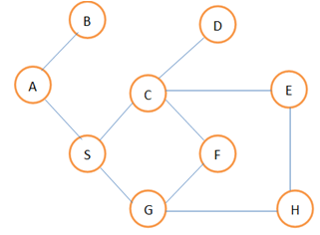 | CO2 | (06)
 | c) | Explain the below approaches to solve recurrences:  - Unrolling the Merge sort recurrence  - Compute the topological ordering for the following graph.  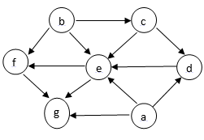 | CO2 | (08)
4. | a) | Outline BFS algorithm and find its worst case efficiency when graph is given by adjacency list representation. | CO2 | (06)
 | b) | Design an algorithm for sorting numbers using divide and conquer method. Apply the same algorithm to sort the list {11,6,12,5,14,22,2,4,17,1} and count the number of inversions. | CO2 | (10)
 | c) | Prove that let T be a BFS tree, let x and y be nodes in T belonging to layers Li and Lj respectively, and let (x,y) be an edge of G. Then i & j differ by at most 1. | CO2 | (04)
 |  | UNIT - III
5. | a) | Discuss the greedy algorithm for Interval Scheduling. Explain the running time of the algorithm. | CO4 | (06)
 | b) | Find the minimum spanning tree for the following graph using Prim’s algorithm. Assume “A” as the starting vertex.  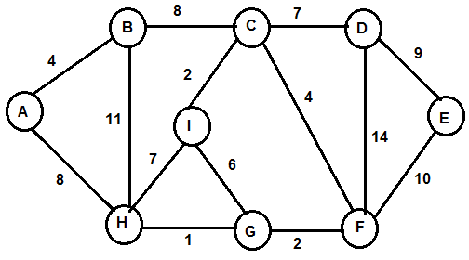 | CO4 | (08)
 | c) | Prove that “Kruskal’s algorithm produces a minimum spanning tree of G”. | CO6 | (06)
6. | a) | Design an algorithm for finding a single source shortest path for a given graph. Apply the same for the following graph. Assume “a” as the source vertex.  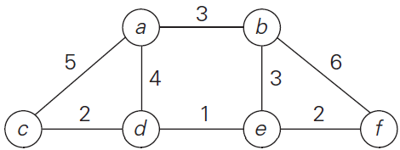 | CO4 | (10)
 | b) | Prove that “Greedy algorithm for interval scheduling returns an optimal set A”. | CO4 | (06)
 | c) | Using Huffman code, find the average code word length for the following table: | CO4 | (04)
  Character | A | B | C | D | E
  Frequency | 2 | 12 | 14 | 4 | 16
 |  | UNIT – IV
7. | a) | - Design an algorithm to find the shortest path for a given graph G using Bellman ford algorithm and compute the time complexity for the same.  - Identify the optimal set of intervals with maximum value for the given set of intervals and weights. | CO4 | (10)
  Interval | Start time | Finish time | Weight
  1 | 1 | 6 | 10
  2 | 2 | 4 | 3
  3 | 5 | 9 | 4
  4 | 7 | 14 | 20
  5 | 11 | 18 | 2
 | b) | - Discuss survey-design problem for a given set of customers and products with an algorithm.  - Calculate the maximum value possible by considering the following instance and knapsack capacity W=10. | CO4 | (10)
  Item | Weight | Value
  1 | 4 | 20
  2 | 7 | 32
  3 | 5 | 20
  4 | 3 | 32
8. | a) | - Design a memoization algorithm to find the optimal weights for weighted interval scheduling problem.  - Identify the shortest path from the source vertex 5 using Bellman Ford algorithm.  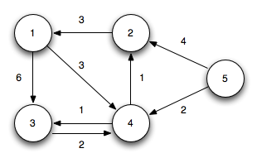 | CO4 | (10)
 | b) | - Discuss the air line scheduling problem with an example.  - Identify the set of optimal set of intervals with maximum value for the following given set of intervals and weights using Memoization technique.  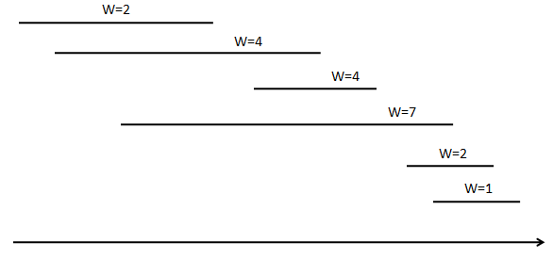 | CO4 | (10)
 |  | UNIT - V
9. | a) | Explain how the Circuit Satisfiability is a NP-Complete problem. | CO5 | (10)
 | b) | Explain Travelling Salesman problem. Justify whether it is a NP-Complete or not. | CO6 | (10)
10. | a) | Define P, NP, NP-Complete & NP-Hard problems. Give examples. | CO5 | (06)
 | b) | Explain the general strategy to prove that problems are NP-Complete. | CO5 | (06)
 | c) | Find all Hamiltonian Paths in the given graph. Prove that Hamiltonian Path is NP-Complete.  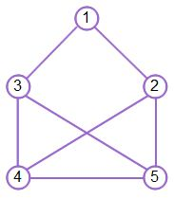 | CO6 | (08)
****************

